Aim:Perform Operations on Stack

Code with Comments:

#include<stdio.h> //header file 1
#include<stdlib.h> //header file 2
#define ss 3
int mstack[3],top=-1;
{
if(top==ss-1) //to check wheather there is space left in stack or not
{
printf("stack is full\n");
return ;
}
else
{
top++;
mstack[top]=ele;
printf("elements pushed inside is %d\n",mstack[top]);
}

}
int pop()
{
if(top==-1) //to check wheather element is there in stack or not
{
printf("stack is empty\n");
return -1;
}
else
{
int ele=mstack[top];
top--;
printf("element popped is %d\n",ele);
}

}
void size() //to check size of elememt
{
printf("size of the stack is %d\n",top+1);
}
void display() //to display element
{
int i;
printf("elements are:");
for(i=0;i<=top;i++)
{
printf("%d ",mstack[i]);
}
printf("\n");
}
void main()
{
int choice,ele;
printf("1.push\n2.pop\n3.size\n4.display\n5.exit\n"); //Creating menu
while(1)
{
printf("enter your choice:");
scanf("%d",&choice);
switch(choice)
{
case 1: printf("enter the element to push into stack:");
scanf("%d",&ele);
push(ele);
break;

case 2: pop();
break;

case 3: size();
break;

case 4: display();
break;

case 5: exit(0);

default:printf("Wrong input");
}
}
}

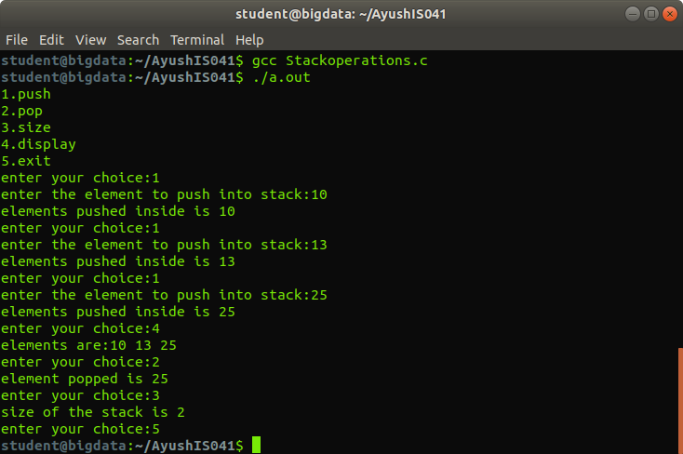
Output:

